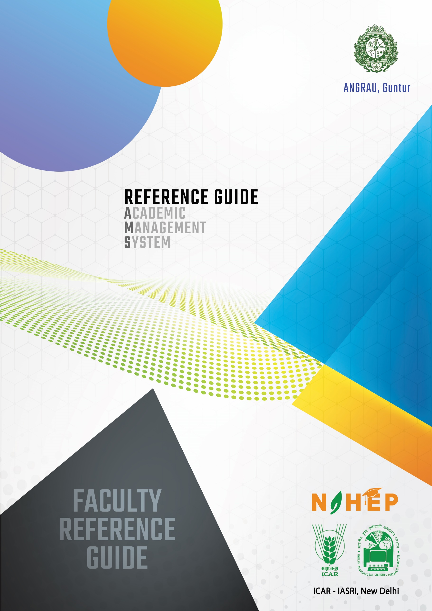

**Reference Manual**

**Academic Management System**

**ANGRAU, Andhra Pradesh**

**User Type: Faculty**

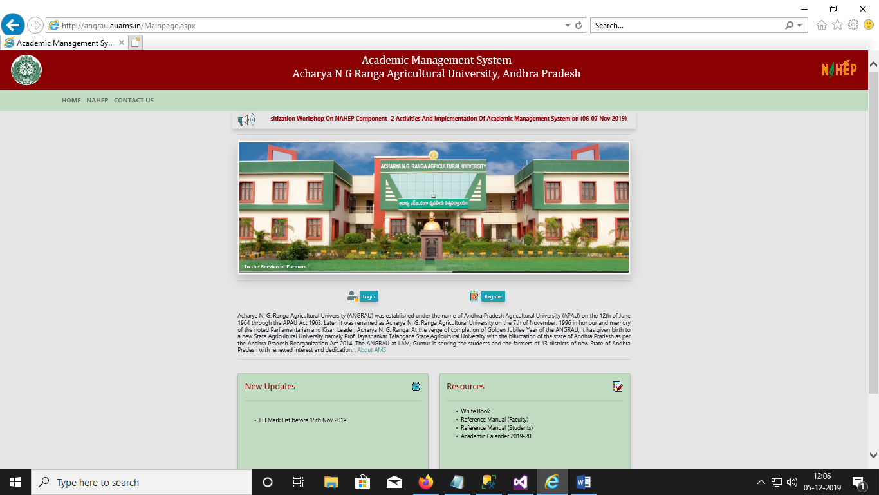

**Contents**

1. Activity workflow diagram of Academic Management System…………..............4
2. Academic Management System Junagarh……………………………...................5
3. User Log in account creation………………………………………………….....6
   1. Accessing the Login Page……………………………………………......6
   2. Signing in for existing users……………………………………..............6
   3. Creation of Log in account for new users ………………...…………......6
   4. Guidelines for filling up registration form…………..........……………...7
4. Personal Profile……………………………………………………………..……10
   1. Edit Basic Profile………………………………………………...............10
   2. Qualifications…………………………………………………….............10
   3. Change user ID and Password…………………………………………....11
5. Course………………………………………………………………….................12
   1. Faculty Approval of Students for course………………………………....12
6. Class Schedule…………………………………………………………………....14
7. Assign Grades…………………………………………………………………….16
   1. Assign Examination scheme…………………………………………..… 16
   2. Entering Class Details…………………………………………….............18
8. Professor & Head Rights and Responsibilities: Board of Studies…………….......21
   1. Adding new courses ……………………………………………………...21
   2. Offering Course in a semester…………………………………………….22
   3. Allocating Faculty to courses …………………………………………....23
   4. Allocating guide to students……………………………………………....26
9. Professor and Head Approve Students Registered Courses …………………...... 27

**Activity Diagram for Using Academic Management System**

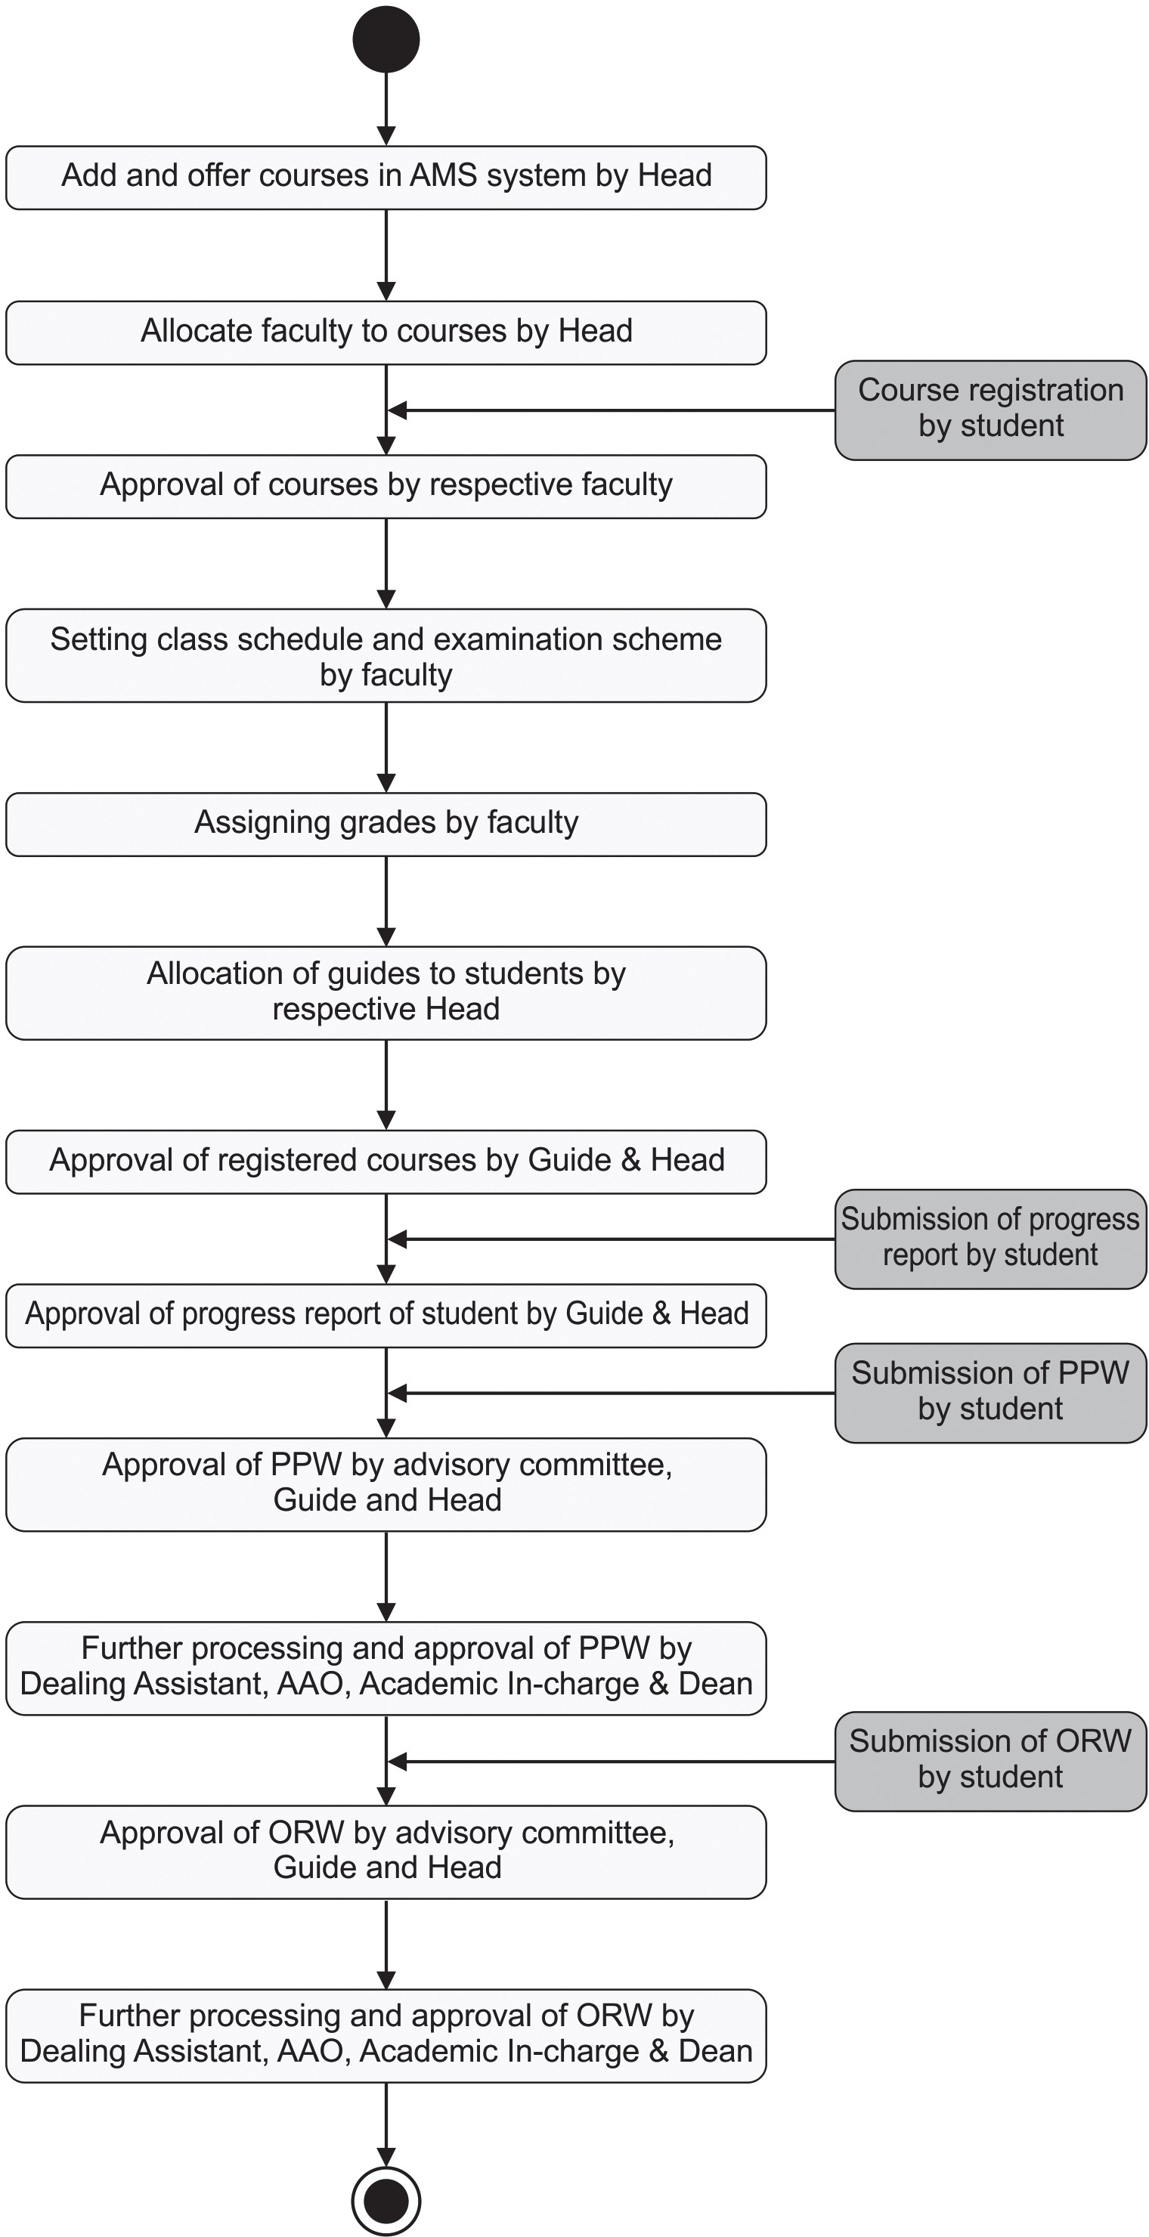

## ACADEMIC MANAGEMENT SYSTEM: ANGRAU

## Andhra Pradesh

Acharya N. G. Ranga Agricultural University (ANGRAU) was established under the name of Andhra Pradesh Agricultural University (APAU) on the 12th of June 1964 through the APAU Act 1963. Later, it was renamed as Acharya N. G. Ranga Agricultural University on the 7th of November, 1996 in honour and memory of the noted Parliamentarian and Kisan Leader, Acharya N. G. Ranga. At the verge of completion of Golden Jubilee Year of the ANGRAU, it has given birth to a new State Agricultural University namely Prof. Jayashankar Telangana State Agricultural University with the bifurcation of the state of Andhra Pradesh as per the Andhra Pradesh Reorganization Act 2014. The ANGRAU at LAM, Guntur is serving the students and the farmers of 13 districts of new State of Andhra Pradesh with renewed interest and dedication.

### 1. User Login Account Creation

#### 1.1 Accessing the Login Page

1. Open latest Internet Explorer version.
2. Type the URL allocated to your university in the address-bar and press Enter Key.
3. You will see the Log-in Page of academic Management System.
4. Click on Tools button and then click compatibility view settings.
5. In **‘Add this website’** textbox, enter the URL **icar.gov.in** in the list and then click on **Add** Button

#### 1.2. Login for Existing Users

1. Click on **Login** button located on Homepage.
2. Enter your Username and Password in the Popup window (Fig. 1.1)

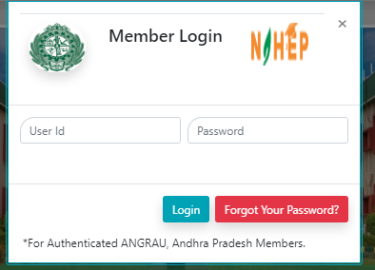

Fig. 1.1: Login page of Academic Management System

#### 1.3. Creation of Login Account for New Users

1. Click on **Register** button on Homepage.
2. User Registration page will be displayed on the screen (Fig.1.2).
3. All fields in registration forms are self-explanatory and the fields marked with * are mandatory to complete the registration form.

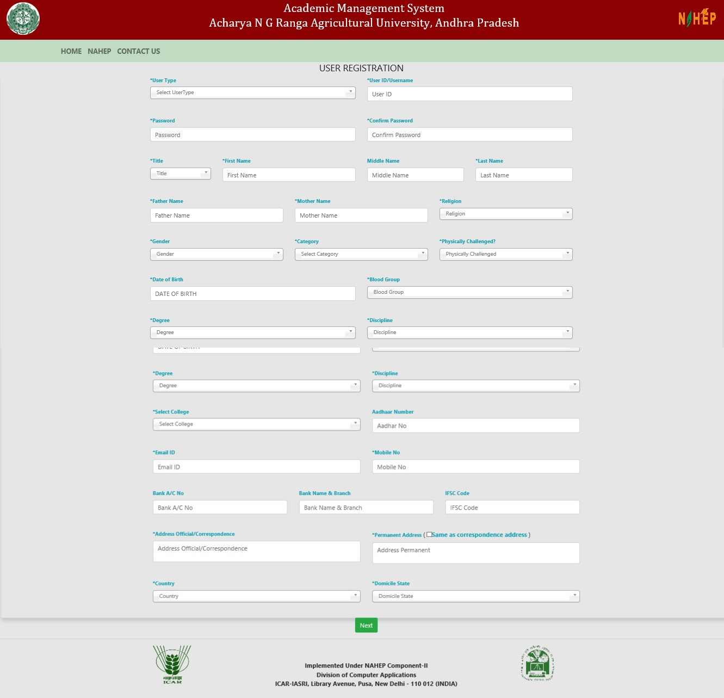

**Fig.1.2: User Registration Page**

**1.4. Guidelines for Filling Up Registration Form:**

* + 1. In the field **\*Create User Name/ID** user has to create a login account which will be used to access the system later on. The user may select the User Name/ID of his/her choice. Faculty are advised to remember/ retain the created User Name/ID for future reference.
    2. Enter your first name in the textbox next to **\*First Name** label.
    3. Enter your father’s name in the textbox next to **\*Father’s Name** label. Please don’t prefix the father name with Sh., Mr. or Dr.
    4. **\*Password** must be at least 7 characters long.
    5. Use calendar to enter **\*D.O.B.**
    6. After filling all the required details, click on **Create My Account** button to create the login account. A user verification screen will be displayed for verifying the entered information

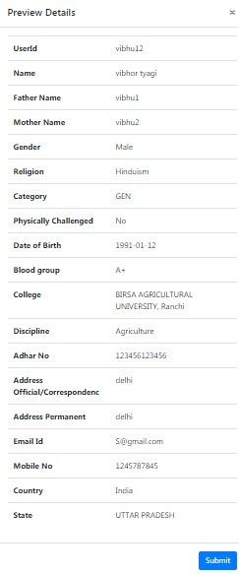

##### Fig. 1.3: User verification screen

1. Click on **Edit** button in Fig. 1.4 to edit the entered information (if required).

**Fig.**

**1.4**

**:**

**Edit Profile**

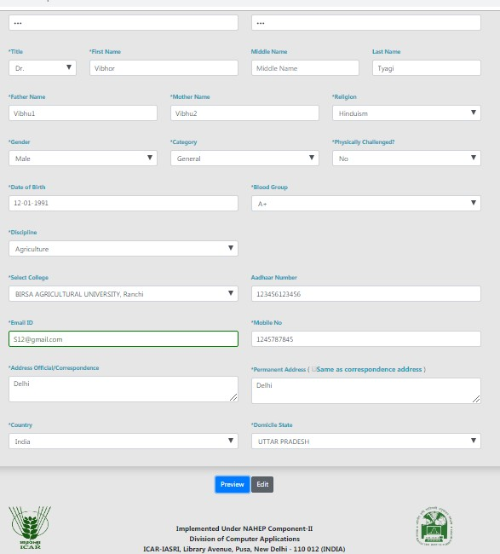

1. Click on **Home** button if you want to abort the process.
2. Click on **Verified** button if the information is correct and want to proceed with creation of user account in the system.
3. The faculty registration is completed.

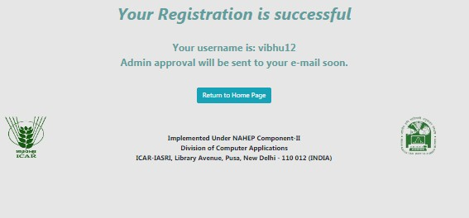

**Fig.1.5: Registration Successfully Completed**

### 2. Personal Profile

#### 2.1 Edit Basic Profile

Faculty can update his/her basic profile containing personal information by clicking on **Personal** Edit Profile.

1. Fill the profile items as per the form shown in Fig. 2.1.
2. Click on **‘Submit’** button to update the changed fields.

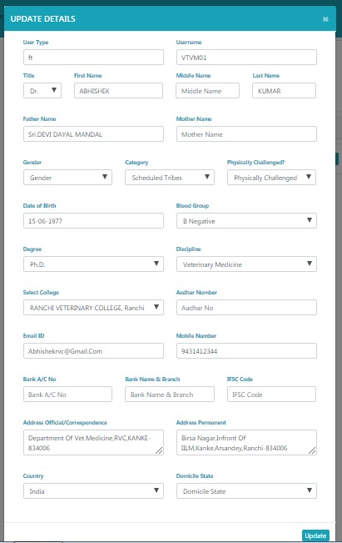

**Fig. 2.1: Edit Profile**

#### 2.2 Qualifications

Faculty can add/delete his/her qualification by clicking on

**Personal** → **Qualifications.**

1. Fill all the details and click on Submit button (Fig. 2.2).
2. A row of qualification will be generated in Qualification Table.
3. Click on **‘Remove’** to delete any qualification.

**Fig.**

**2.2**

**:**

**Show**

**Qualification**

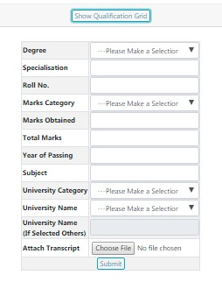

#### 2.3 Change User ID and Password

Faculty can change his/her User ID & Password of his/her login account by clicking on

##### Personal → Change User ID and Password

1. Enter new user ID in **‘New User ID’** text box (Fig. 2.3).
2. Enter new password and confirm password in **‘New Password’** and **‘Confirm Password’** text-boxes respectively.
3. Click on **‘Submit’** button.
4. The user Id and password will be changed in the system.

**Fig.**

**2.3**

**:**

**Change**

**Password**

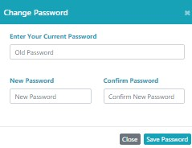

### 3. Course

#### 3.1 Faculty approval of students for a course

Once a student selects and register a course to study in the semester, the faculty may approve/ disapprove the student to take that particular course. To approve/ disapprove a student from the selected course, click on

**Courses** →**Faculty Approval of Students.**

1. Click on the course number to approve students registered for the course (fig.3.1)

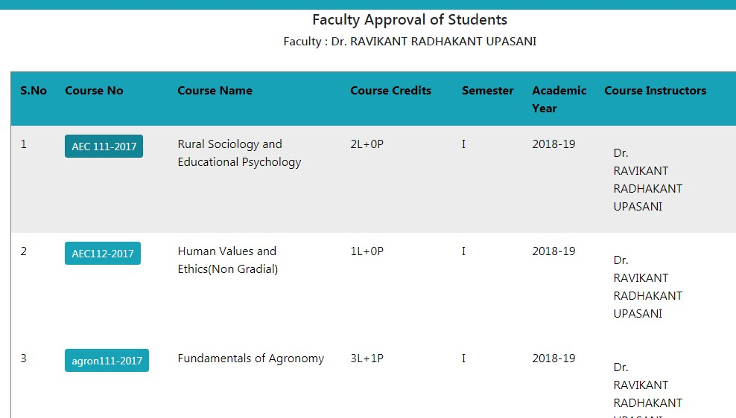

##### Fig. 3.1: Faculty view of the Course(s) Registered by the Students

1. The next page will display list of students registered in a particular course (Fig.3.2)

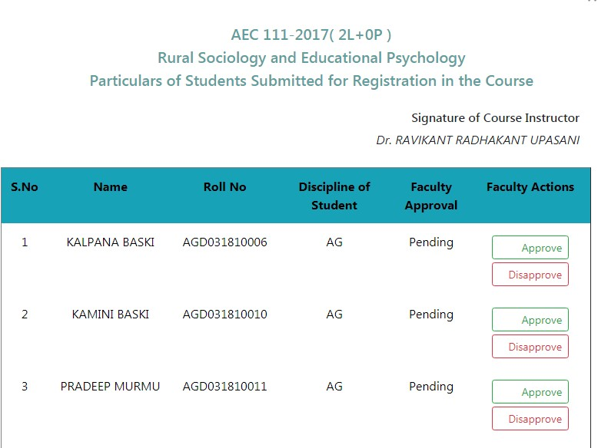

##### Fig 3.2: Faculty approval of student registration for a course

3. Click on **Approve / Disapprove** under Faculty Action column to accept/ reject the student’s request. (Fig 3.3)

**Fig 3.3**

**Approve/Disapprove**

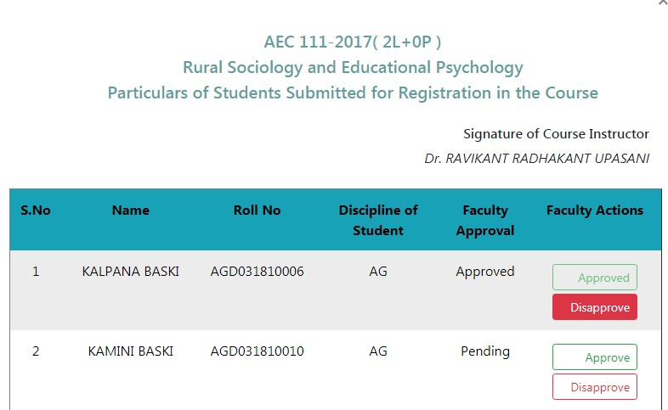

### l4. Class Schedule

This module is used for creating e-learning activities related to a particular course. The faculty can manage the class room activities of a particular course such as details of topics to be taught in the class, uploading the resources for lecture material, assignments etc. To access this module, click on

#### Courses → Class Schedule

1. Select Course No. from the table given in (Fig. 4.1**)**

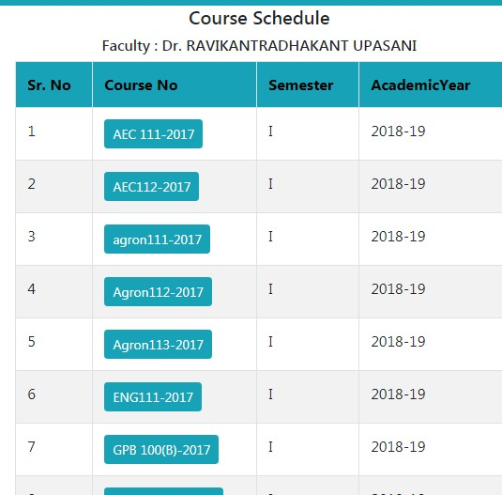

#### Fig. 4.1: Course Schedule

1. Select Course No. then add new topic. (Fig 4.2)
   1. Select Theory/Practice
   2. Enter Topic Name
   3. Select Start Date of the Course
   4. Select Completion Date of the Course
   5. Enter No. of Lecture
   6. Select Faculty and then click on submit button.

**Fig.**

**4.2**

**:**

**Add New Topic**

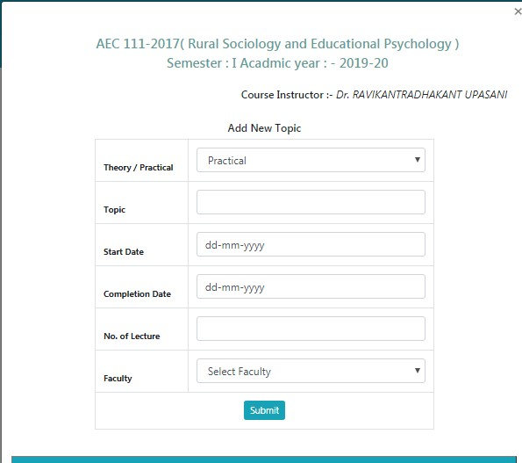

1. Remove topics from the list by clicking on remove button. (Fig 4.3).

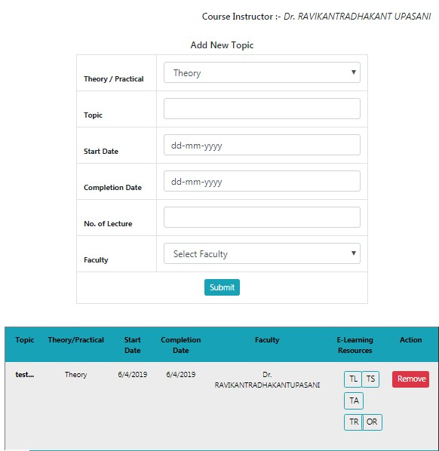

**Fig 4.3 Add New Topic**

#### 5. Assign Grades

##### 5.1 Assigning Examination Scheme

Before entering the marks of students for a particular course, the faculty first has to of that particular course. To assign examination scheme.

Click on Courses→ **Assign Grades.**

1. Select **Academic year** and **Semester** from the list and click on

**Submit** button (Fig. 5.1)

1. Next page will display list of courses offered in the current semester. Select a particular course and click on **Enter Examination Scheme** button (Fig. 5.2)
2. Click on **Assign** button for assigning examination scheme of a particular course (Fig. 5.3). After that enter the examination scheme of the course as per rules of NDRI Deemed University.
3. To edit the examination scheme, first delete the current scheme by

clicking on **Delete** button (Fig. 5.3) and then click on **Assign** button for assigning new scheme.

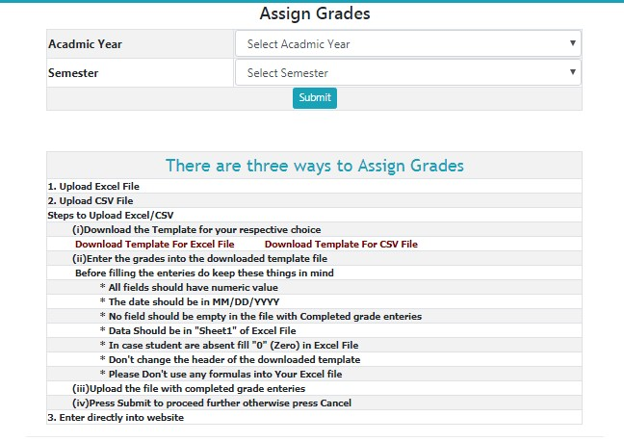

**Fig. 5.1: Showing academic year and semester dropdown**

**Fig.**

**5.2**

**:**

**Selecting course name**

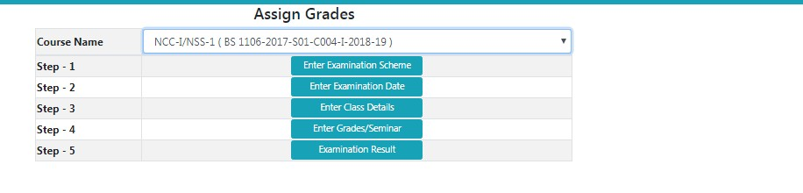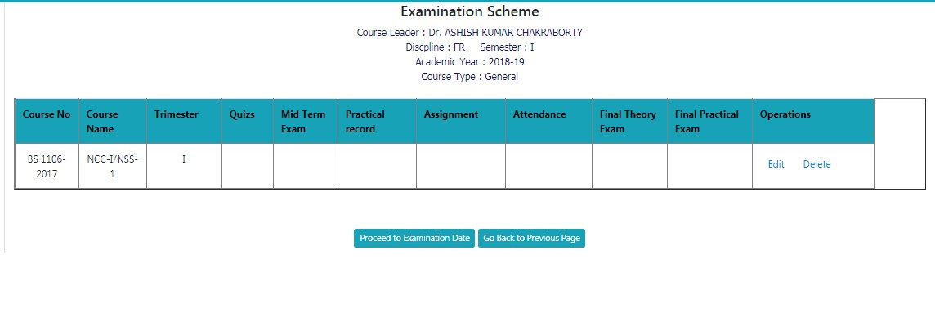

**Fig. 5.3: Setting examination scheme for a course**

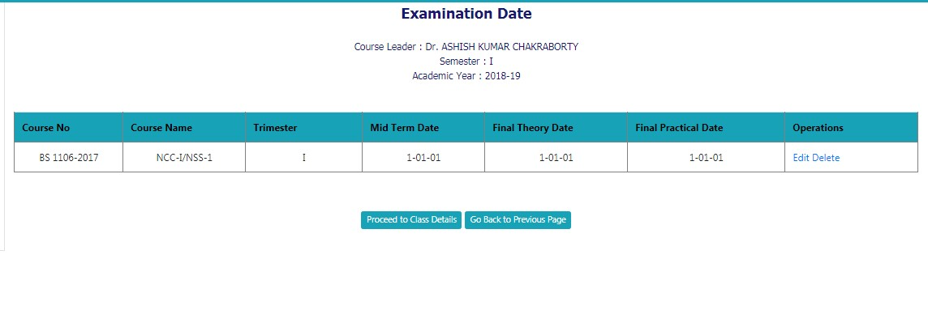

**Fig. 5.4: Assigning examination date of a particular course**

##### 5.2 Entering Class Details

This module is to provide information above number of theory/practical lectures to be given and actual number of lectures delivered. Class details of a particular course can be entered by clicking **Courses >> Assign Grades.**

1. Select **Academic year** and **Semester** from the list and click on **Submit** button (Fig.5.5).
2. Next page will display the list of courses for the current semester. Select a particular course and click on **Enter Examination Date** button. (Fig. 5.6) You can also enter class details of a particular course by clicking on **Proceed to Class Details** hyperlink in Fig.5.7.
3. Next page will ask for entering number of lectures of **theory/practical scheduled** and **actually given/delivered** for a particular course in the semester. After filling all the number of lectures of individual course instructor and in total, click on **Submit** button in (Fig. 5.10)

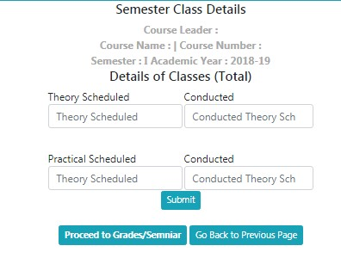

**Fig. 5.10: Entering class details of a particular course**

## Assigning Grades

Faculty can assign grades of a particular course by clicking **Courses >> Assign Grades.**

Select **Academic year** and **Semester** from the list and click on **Submit** button (Fig. 5.5).

1. Next page will display the list of courses for the current semester. Select a particular course and click on **Enter Grades** button (Fig. 5.6).
2. Grades can be entered directly through the form or through CSV file (Fig. 5.11). To assign grades through CSV file click on **Upload CSV file** hyperlink located on the top right hand corner in Fig. 3.13. This will lead to open a new window shown in Fig. 3.14. Follow the steps given below to upload the class schedule through CSV file: -
   1. Download the template for assigning grades.
   2. Enter the grades into downloaded template file. While filling the entries in the template, kindly take care of the following points: -
3. The date should be in MM/DD/YYYY format.
4. No field should be empty in the file.
5. Don’t change the header of the downloaded template.
   1. Press **Upload CSV** button to upload the file.
   2. Enter the remarks for a particular student in the column **“Select Remarks”** for a particular student in Fig. 3.14.
   3. Similarly select examination type. For example:

Select **“Regular”** for assigning grades in regular examination.

* 1. After selecting examination type and remarks for each student click on Submit & Proceed button for completing the process of assigning grades.

1. To edit the entries of grades for a particular student, first remove it by clicking **Remove**
2. Button (Fig. 3.12) and then assign new grades to the same student.

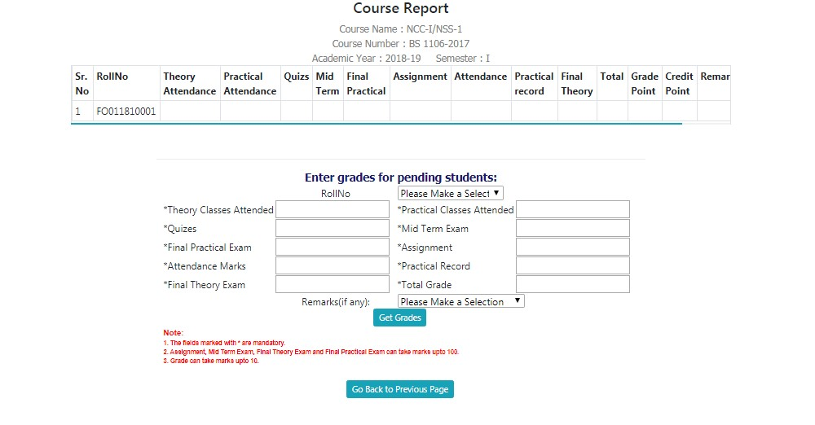

**Role of Professor and Head**

**6** **Professor & Head Rights and Responsibilities:**

Professor & Head of each discipline is the chairman of Board of Studies having rights to add courses offer courses, allocate faculty to these courses, and allocate guide to each student. All these tasks are carried out by clicking on BoS Menu. If a professor and head is chairman of more than one BoS (discipline), then he/she has to first select the discipline for which he/she is acting as chairman of BoS. To select the discipline, click on Role menu available on right hand side of main menu. Then click on Change button (to change the discipline) in the new window displayed on the screen.

**6.1** **Adding New Courses**

1. Professor & Head needs to add new courses in each semester by clicking on BOS ->Add Course.

2. A new screen will be displayed as shown in (Fig. 6.1) To add a New Course, Enter Course Number Course Name and Induction Year in the textboxes.

3. Click on **‘Add Course’** button (Fig. 6.1)

4. A new row will be generated. For updating newly added or existing courses click on **‘Modify button’** (Fig. 6.1). A new page will be displayed where syllabus, credit hours and other particulars of the course can be added/updated in (Fig. 6.2)

5. Click on **‘Modify’** button, after filling all the required details in (Fig. 6.2)

6. For deleting the course click on ‘**Remove’** button (Fig.6.1). One can delete only that course which is not offered to students or registered by any student.

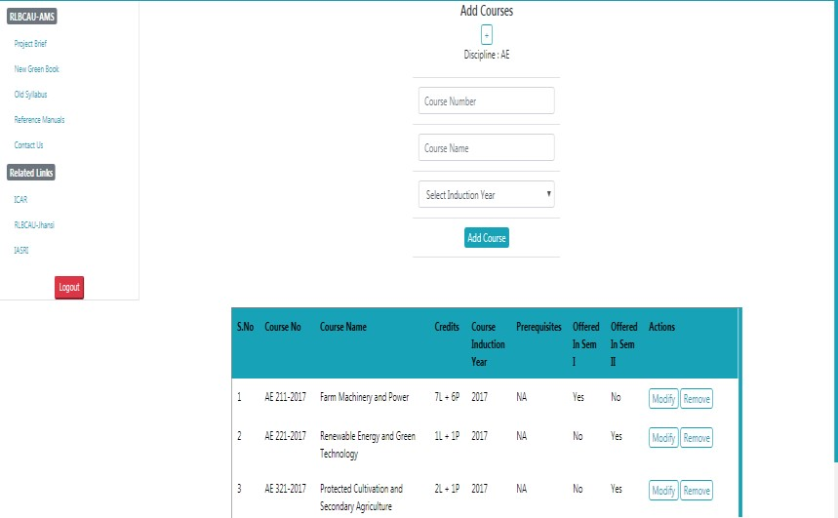

**Fig. 6.1: Adding New Courses in Semester**

**6.2** **Offering Course in a Semester**

The newly added courses in each semester are to be offered to students for Registration. To offer the course. Click on **BOS------Offer Courses**.

1. Select **Academic Year** and **Semester** e.g. 2017-18 and I Semester as shown in (Fig. 6.3)
2. To add new courses in the semester, click on **Add Courses Offered in Semester** button (Fig. 6.3)
3. The new page will be displayed (Fig. 6.4).
4. Select courses from **Courses** list box and move them to Selected **Courses** list box using **move right** Button (Fig. 6.4).
5. You can remove course(s) (if required) from **Selected Courses** List box by selecting the course(s) and clicking on **move left** button (Fig. 6.4).
6. Click on **‘Save Changes’** button (Fig. 6.4).

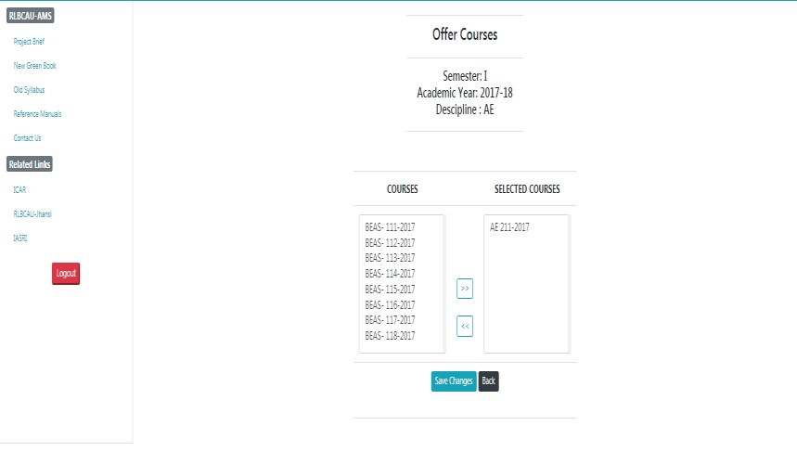

#### Fig. 6.2 Offer Courses

**Fig. 6.3: List of courses offered in a semester**

* 1. **Allocating Faculty to Courses**

Professor & Head have to allocate faculty to each course by clicking on **BoS Allocate Faculty.**

1. The next screen will display all offered courses in the current Academic Year & Semester (Fig. 6.5).
2. Click on **Allocate** for allocating a faculty to a course.
3. The allocate faculty form will appear (Fig. 6.6).
4. Select the faculty members as **Course Leader, Course Associate 1** and **Course Associate 2** for the particular course. The faculty may be from any discipline. If you want to select it from the same discipline, select it from dropdown otherwise click on **Choose from Other Discipline** (Fig. 6.6).
5. After clicking **Choose from Other Discipline** in (Fig. 10.6) a new screen will be displayed where you can select the discipline. Click on Submit Button after selecting discipline in (Fig.10.7). A new screen will be displayed where you can allocate the faculty from selected discipline, by clicking on **Allocate** button. Click on **Reset** button to deselect the selected value (Fig. 10.8).
6. After selecting all the faculty, click on **Allocate** button (Fig. 10.6).
7. Click on **‘Reset’** button to deselect all selected values (Fig. 10.6).

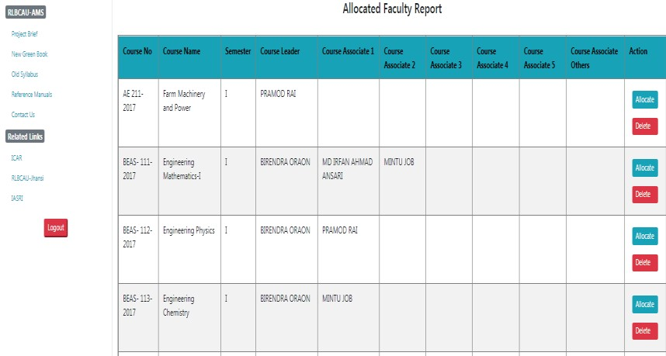

**Fig. 6.5: List of Courses Along with Allocated Faculty**

#### Fig. 6.6: Allocating faculty to a course

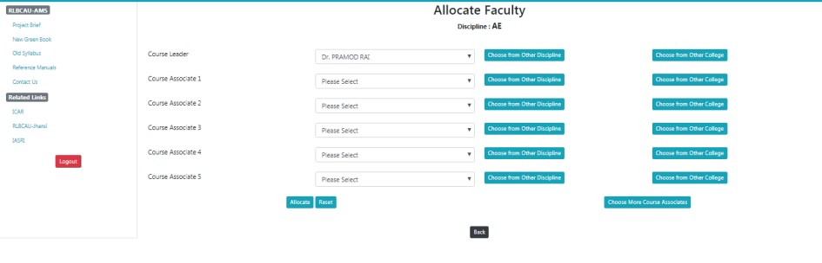

**Fig. 6.7: Select other Discipline(s)**

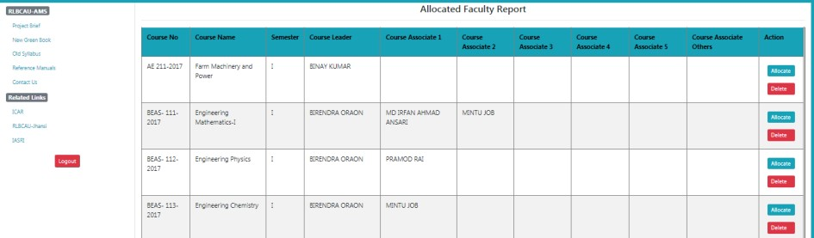

**Fig.**

**6**

**.8:**

**Select**

**faculty**

**for**

**the**

**course**

### 6.4 Allocating guide to students

Each student is to be allocated a guide in the division. To allocate a guide to a student click on **BoS** Allocate Guide

1. Enter Enrollment year and degree in field shown in (Fig. 6.9).
2. After Selecting Enrollment year and degree click on **Submit** button (Fig. 6.9).
3. The next screen will display list of students enrolled in selected year and degree programme. Click on **Allocate** for allocating the guide to a student (Fig. 6.10).
4. After selecting the guide from **Chairman Advisory Committee** dropdown list, click on **Allocate** button (Fig. 6.11).
5. Click on **Reset** button to deselect the selected value (Fig. 6.11).

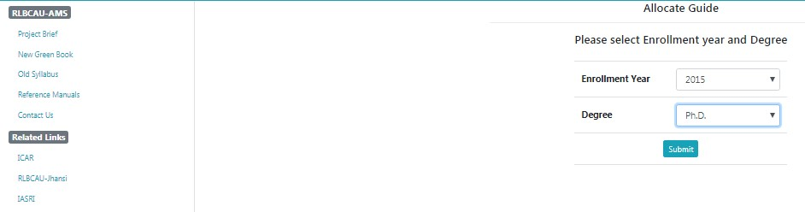

#### Fig. 6.9: Selecting the Enrollment Year and Degree

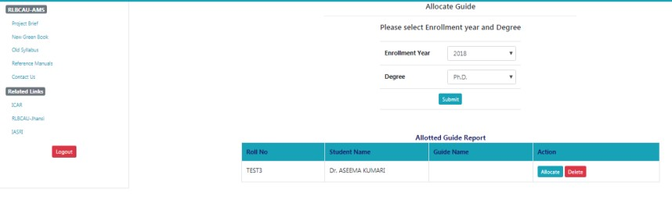

#### Fig. 6.10: Allocate Guide

### 

### 

**Fig. 6.11 Chairman Advisory Committee**

### 7. Professor & Head approve students registered courses

Professor & Head needs to approve registered courses of students by clicking on **Courses Professor Approval of Students**.

1. Select academic year and semester in Fig 7.1 and then click on **Submit** button.
2. The next page will show the list of students of the concerned discipline (Fig.7.2) along with the status.
3. Click on a student name to see all his registered courses (Fig.7.3).
4. Click on **Approve** button to register the student. The **Approve** button appears only if all courses are approved by faculty as well as by guide.

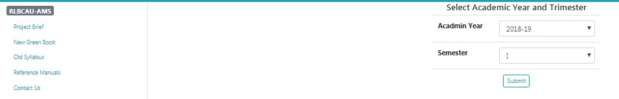

#### Fig. 7.1: Select academic year & semester

#### 

#### Fig. 7.2: List of students in the selected academic year & semester

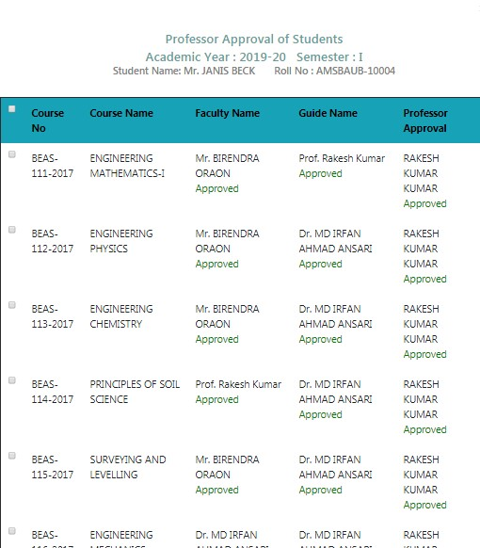

#### Fig. 7.3: Approval of courses by Professor & Head