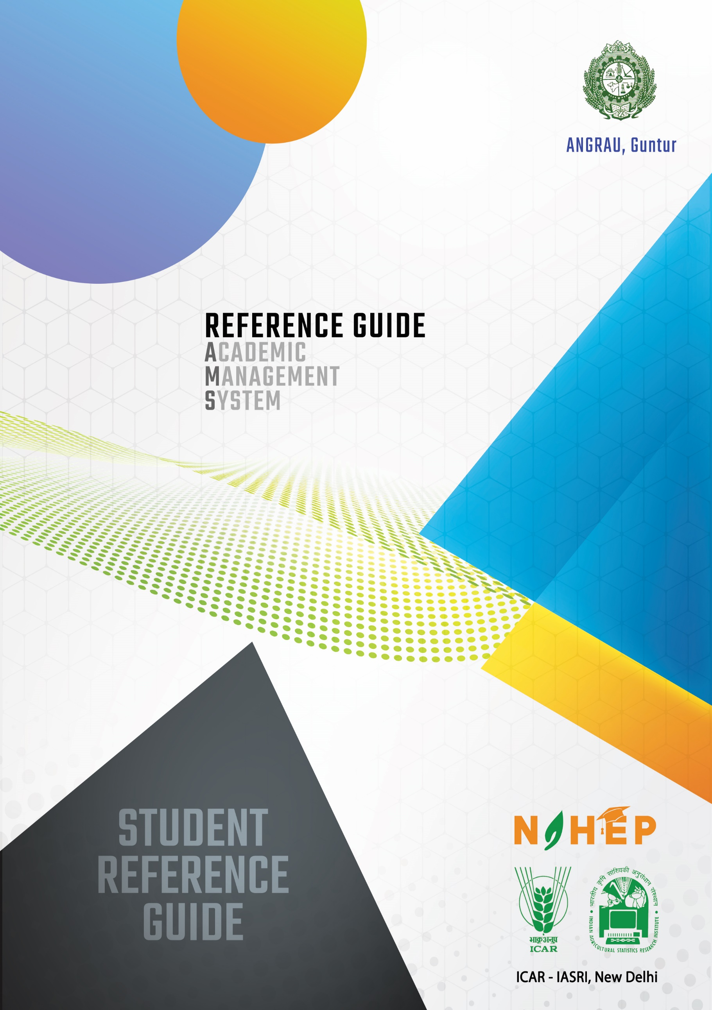

# Reference Manual

**Academic Management System**

**ANGRAU, Andhra Pradesh**

**User: Student**

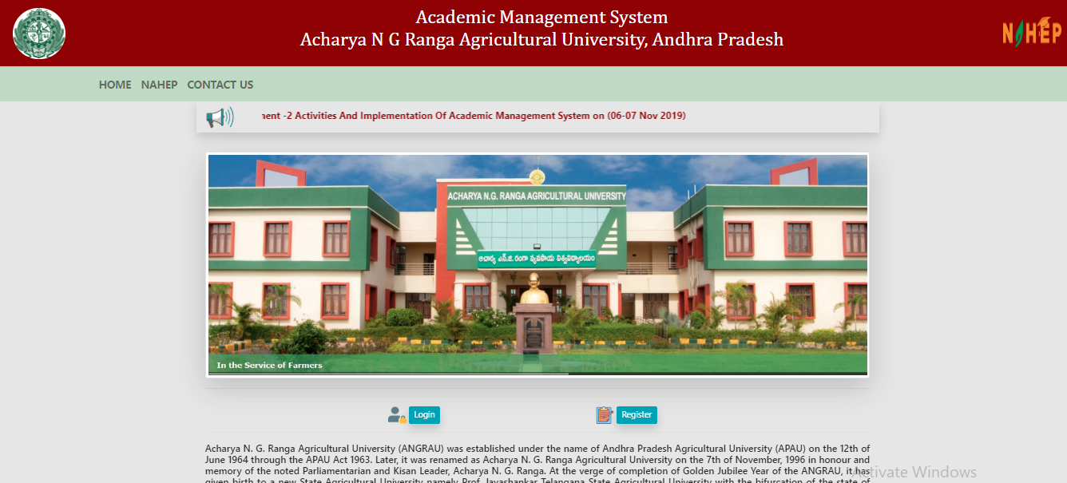

# Contents

1. Introduction 3
2. Workflow 4
3. User login account creation 5
   1. Accessing the Login Page 5
   2. Signing in for Existing Users 5
   3. Creation of Login Account for New Users 5
   4. Guidelines for filling up registration form… 6
4. Personal settings 9
   1. Add Qualifications 9

4.2. Basic Profile 10

1. Fee Payment 13
2. Plan of Post Graduate Work (PPW) 13

# Introduction

Academic Management System (AMS) has been customized by the NAHEP Component 2 Project Team at ICAR-Indian Agricultural Statistics Research Institute (IASRI) for the implementation at various Agricultural Universities. It is a web enabled system for management of all the various academic activities of the university. The system caters to the needs of different users: Dean, Registrar, Professor, Head, Guide, Faculty, Teacher, Student, Administrators and Officials for performing their assigned tasks. This system has been designed in a modular approach with in-built work flows. AMS ensures that the individuals responsible for the next task are notified and receive the data they need to execute at their stage of process. At present five modules have been envisaged viz., Student Management, Faculty Management, Course Management, Administration Management and E-Learning.

AMS facilitates in automation of various academic processes of the university and enhances the efficiency of the overall system by saving time and efforts involved in manual processes. It continues to be customized as per the respective needs of the various universities.

# Activity Diagram for using Academic Management System (AMS)

This activity diagram Fig. 1 for AMS shows the workflow of the whole system.

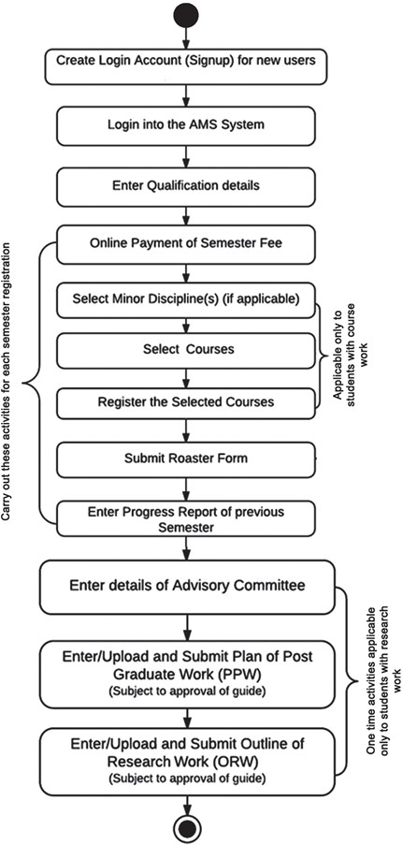

Fig .1: Activity Diagram for AMS, User type: Student

# User login account creation

All the students need to register using the register button and already registered users need to login to their account using their credential in Login page

# Accessing the Login Page

1. Open latest Internet Browser.
2. Type [URL assigned to your university for AMS](http://auj.auams.in/) in the address-bar and press Enter Key.
3. Home page of Academic Management System, of the University will be displayed on the screen.

# Signing in for Existing Users

1. Click on **Log In** button located on right-hand side below the image on the Homepage
2. Enter your User ID and Password in the Popup window (Fig. 1.1).

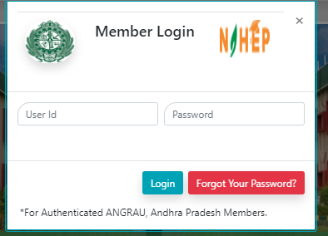

Fig.1.1: Login page of Academic Management System

# Creation of Login Account for New Users

1. Click on **Register** button located on left-hand corner below the image on the Homepage.
2. User Registration page will be displayed on the screen {Fig.1.2 (a) & (b)}.
3. All fields in registration forms are self-explanatory and the fields marked with * are mandatory to complete the registration form.

# Guidelines for filling up registration form:

1. In field **\*User Type** Select user type as either student or faculty from the drop down list.
2. In the field **\*Create User Name/ID** user has to create a login account which will be used to access the system later on. The user may select the User Name/ID of his/her choice. The students are advised to remember/ retain the created User Name/ID for future reference.
3. **\*Password** must be at least 7 characters long. The filed password and confirm password are case sensitive
4. Enter your first name in the textbox next to **\*First Name** label. Please do not use initial letters in first name.
5. Enter your father’s name in the textbox next to **\*Father’s Name** label. Please don’t prefix the father name with Sh., Mr. or Dr.
6. Enter your Mother’s name in the textbox next to **\*Mother’s Name** label. Please don’t prefix the Mother name with Smt., Mrs. or Dr.
7. Select the religion, gender and the PWD status from their respective drop down list below the labels **\*Religion**, \***Gender**, and**\*Physically Challenged.**
8. Use calendar to enter**\*D.O.B.**
9. Select the blood type from the list shown below the label **\*Blood Type**
10. Select the degree, discipline and college from the drop down list below the labels **\*Degree,**

# *Discipline and *Select College.

1. Enter 12 digit ADHAR number in the text area below the label **\*Adhar Number**.
2. Enter your E-Mail Id and Mobile number in the text area below the labels **\*E-mail id** and

# *Mobile

1. Enter your bank details under the labels Bank Ac/No, Bank name/branch name and IFSC code. These are not mandatory fields.
2. Enter your correspondence and permanent address in the text area below the labels

**\*Address Official/Correspondence** and **\*Permanent Address**. If both of your addresses are same then you can select the check box same as correspondence address.

1. Select the country and domicile state from the drop down list below labels **\*country** and

# *Domicile.

1. Click on **Home** button in Fig. 1.2(a), if you want to abort the process.
2. Click on **next** button in Fig. 1.2(b), if the information is correct and want to proceed with creation of user account in the system.
3. After clicking next you will have two options edit and preview, you can edit your details by clicking on edit and preview the entered details by clicking on preview.
4. After the preview you can submit the data displayed in Fig: 1.3.
5. Wait for the approval by Dealing Assistant/ Admin to login into the system.
6. Once the user is approved, then student can login into the system. After login, user will see the screen displayed in Fig. 1.4.

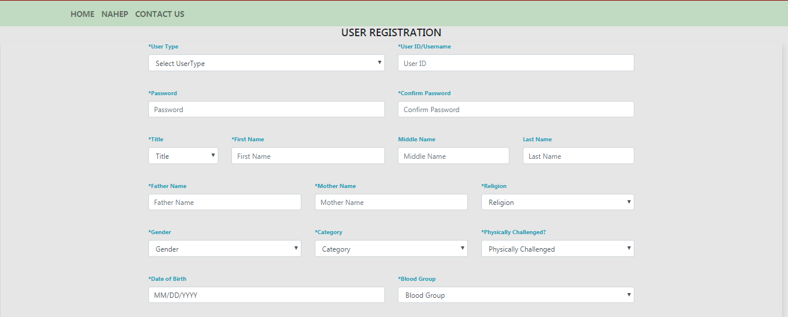

Fig. 1.2 (a)

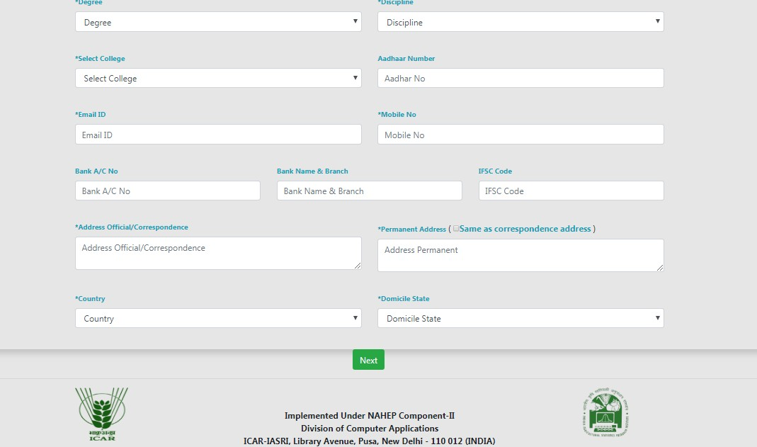

Fig 1.2(b): User registration form (Students)

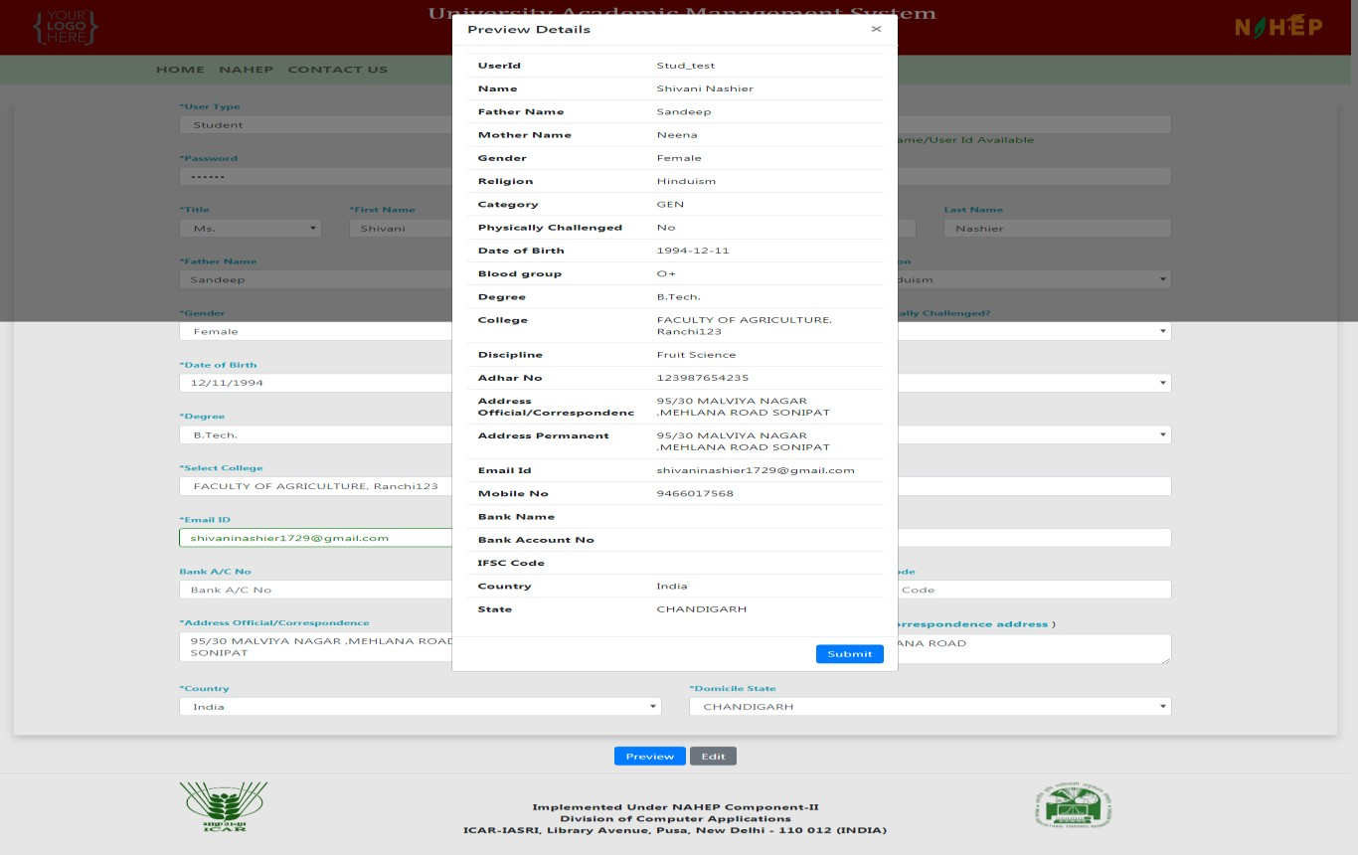

Fig. 1.3: User verification screen

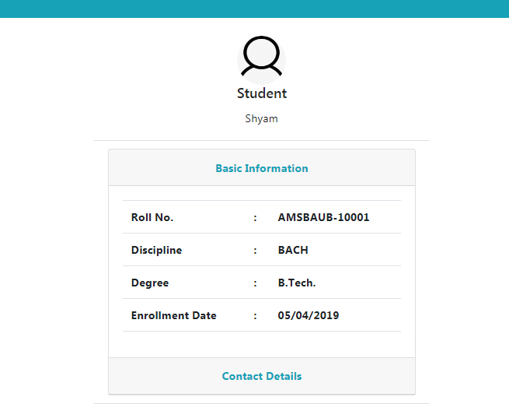

Fig. 1.4: Home page of a user

# Personal settings

Here user can change his/her personal settings like, they can add qualifications and edit their profile

# Add Qualifications

Student can update his/her profile by clicking on **Personal >> Qualification**

1. Fill the items as per the form (Fig. 2.1).
2. Click on **‘Submit’** button the qualification added is updated to the student’s profile.
3. On Click on show Qualification Grid button the grid shows the qualifications added
4. On click on the Remove button in the grid, you can delete the entire row of the respective record.(fig 2.2)

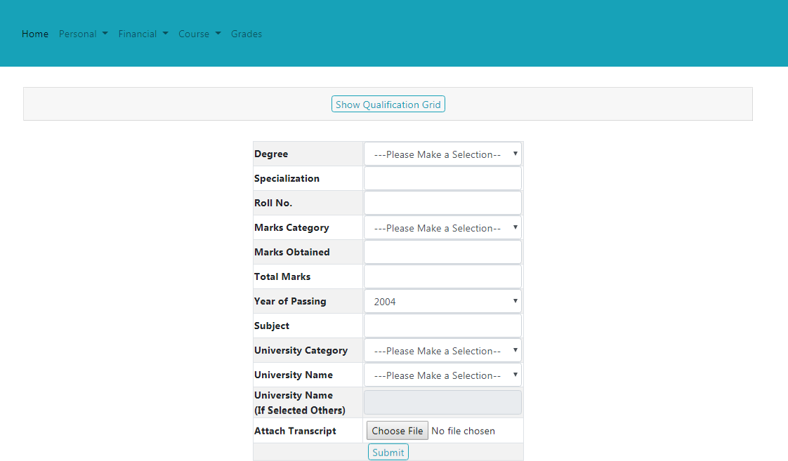

Fig. 2.1: Adding Qualifications & Listing

# Basic Profile

Student can add his/her qualification by clicking on Personal >> Basic Profile

1. On clicking Change Profile pic ,you can change your current profile picture or add a new picture(Fig 2.3)

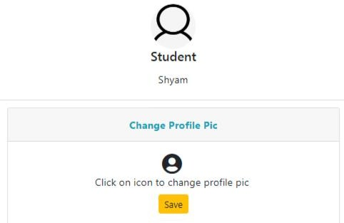

Fig 2.3: Change profile Pic

1. On clicking basic profile we can edit basic Details (Fig :2.4)
2. On Clicking contact info we can update the Contact information(Fig:2.5)
3. On Clicking Update profile the Changes done in the profile are saved
4. User can change their password by clicking on Change password button (Fig :2.6)
5. User can verify their email Id by getting an OTP on their Email ID.(Fig :2.7)

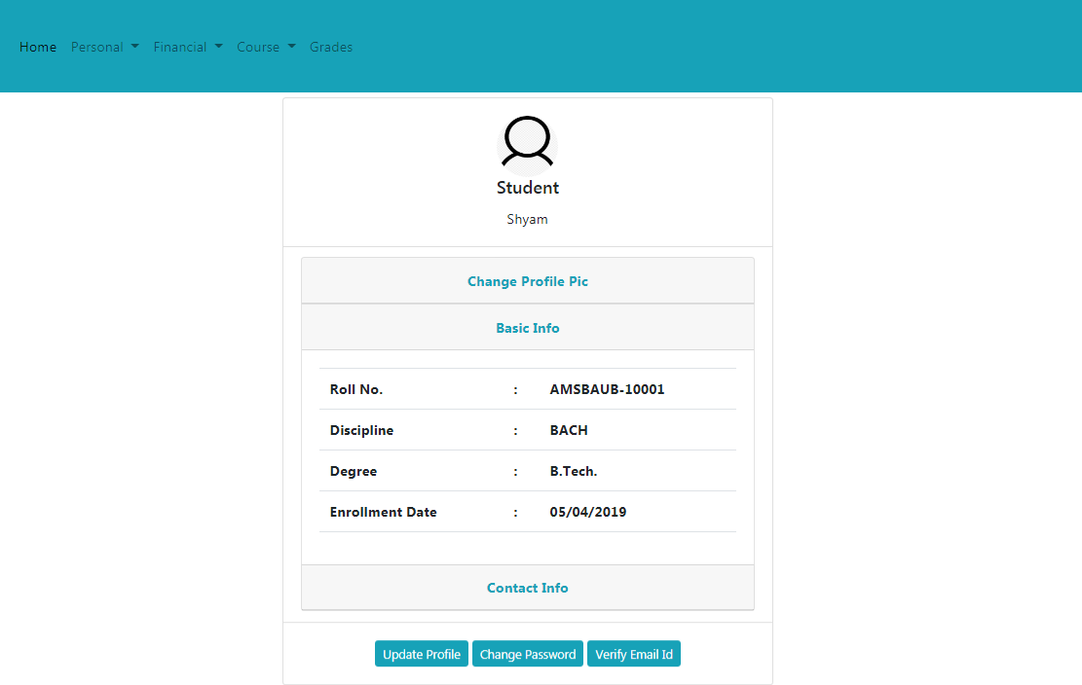

Fig 2.4: Edit Basic Profile

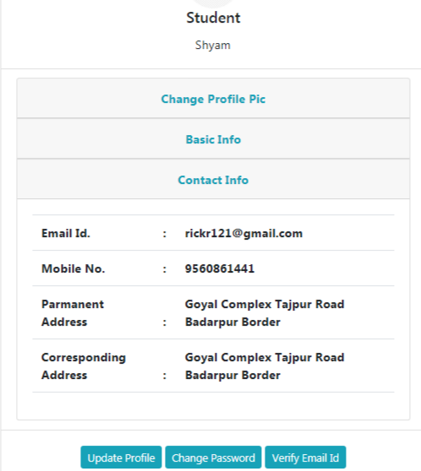

Fig 2.5 Edit Contact Information

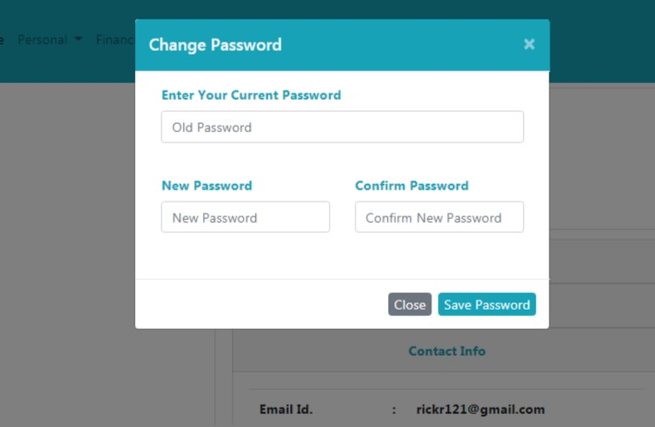

Fig: 2.6: Change Password

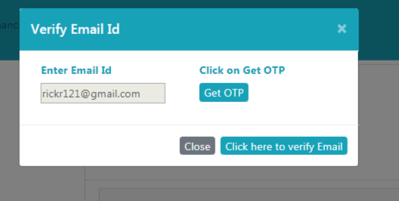

Fig: 2.7 Verify Email

# Fee payment module

The students can pay semester fee and other type of fee such as re-totaling, supplementary, due hostel charges in offline mode. The fee submission details will be submitted online in by Clicking on **Financial >> Fees**. The students will be asked a few simple self- explanatory question(s) to submit the exact fee paid by the student as shown in Fig. 3.1.

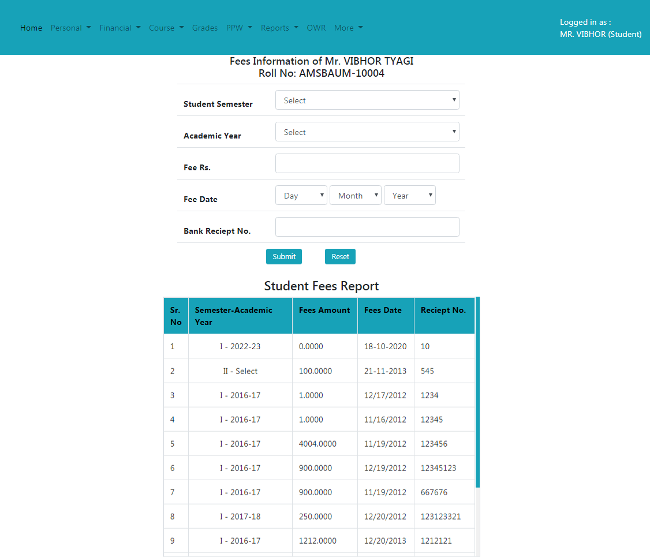

Fig: 3.1: Fee Submission details

The student fee report grid shown below the fee submitted details shows the details of fee submitted by student.

# Plan of Post Graduate Work (PPW)

**6.1 Preparing PPW by a Student**

A student Plan of Post Graduate Work (PPW) contains various options for selection of minor discipline, major and minor courses, details of advisory committee, thesis problem and submission of PPW. The PPW submitted by a student needs to be approved in a sequence by his/her Advisory Committee Members, Guide, Professor & Head, Dealing Assistant, AAO, Academic In-charge and Dean of the discipline.

# Choosing Minor Discipline

Student can choose his/her major/minor discipline by clicking on **PPW >> Minor Discipline.**

* 1. As per requirement select first, second, third and fourth minor disciplines from the respective options **‘First Minor Discipline’, ‘Second Minor Discipline’, ‘Third Minor Discipline’** and **‘Fourth Minor Discipline’** dropdown menu (Fig. 4.1).
  2. Select Supporting courses (if applicable) from **Supporting Courses**’dropdown menu as per need
  3. Select Audit courses (if applicable) from ‘**Audit Courses**’dropdown menu as per need.
  4. Select Compulsory courses (if applicable) from ‘**compulsory Courses**’dropdown menu as per need.
  5. After selecting relevant information click on **‘Submit’** button.

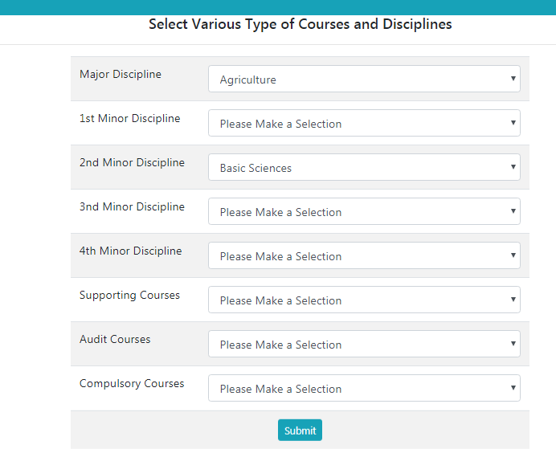

Fig: 4.1 Choosing Disciplines

# Choosing Courses

Student can choose/allocate his/her courses offered by the division/guide, by clicking on **PPW >> Courses.**

* + 1. Select academic year and semester from **‘AcademicYear’** and **‘Semester’**

Dropdown (Fig. 4.2). and click on add semester.

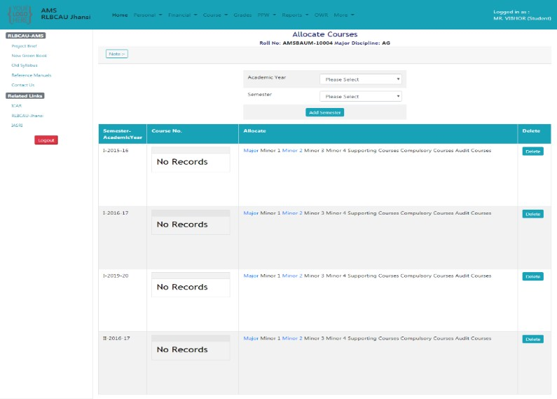

Fig: 4.1 Choosing Courses

* + 1. After adding a semester we can add new courses offered for that semester and academic year and they will be displayed in the grid shown below

# Constitution of advisory committee

After constitution of advisory committee, the student is supposed to enter details of his/her advisory committee members by clicking on **PPW >> Advisory Committee.**

1. Nextscreencontainlinks **‘Choose Major Member’,‘Choose Minor1 Member’,‘Choose Other Member’** etc. for selecting members from major, minor and other disciplines ( Fig. 4.4).
2. To select a member from major discipline, click on **’Choose Major Member’** (Fig. 4.4).
3. This will show next window containing **‘Faculty Members’ and ‘Advisory Committee Members’** list boxes (Fig. 4.5).
4. Select a faculty member name from **‘Faculty Members’** list box and move it to **‘Advisory Committee Members’** list box by **right move >> button**.
5. A faculty member name in **‘Advisory Committee Members’** list box may be moved back to

**‘Faculty Members’** list box by **left move << button**.

1. Click on **‘Save Changes’** button (Fig. 4.5).
2. The selected major faculty member will appear in a row below **‘Choose Major Member’**

(Fig. 4.4).

1. In similar manner, members from remaining discipline may be selected (Fig. 4.4).

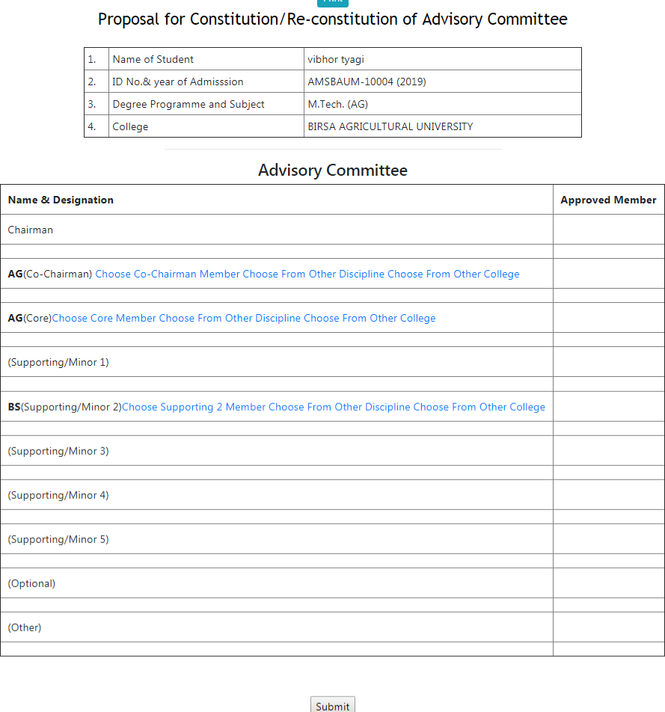

Fig. 4.4: links for selecting advisory committee members

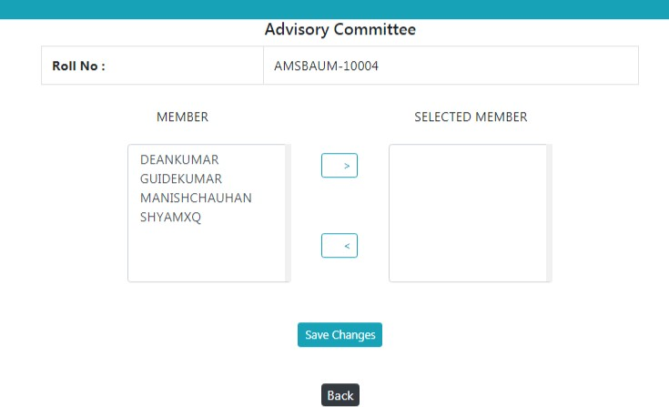

Fig. 4.5: Selecting advisory committee members

# Submitting thesis abstract

At this stage, students are expected to submit his/her thesis abstract as a Plan of Post Graduate Work. To submit thesis abstract click on **PPW >> Thesis Problem.** Kindly insure that there is no blank space in the file name to be uploaded. Click **‘Submit’** button to upload the thesis abstract file and other information in the system.(Fig. 4.6).

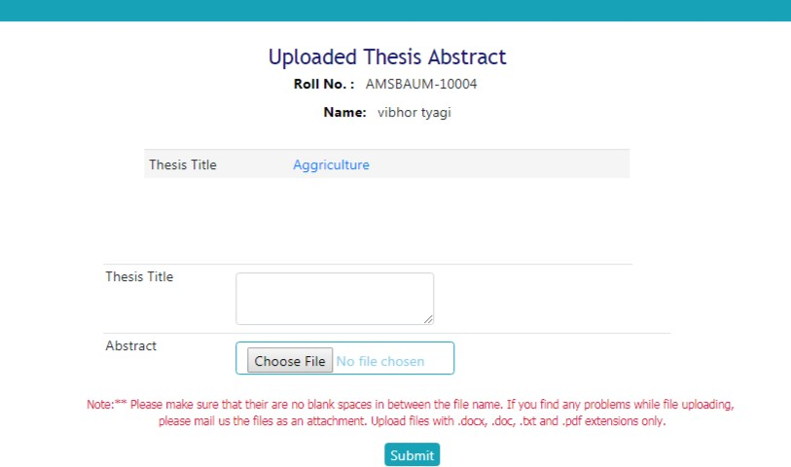

Fig. 4.6: Uploading thesis title and abstract by a student

# Submitting PPW

This module relates to record the planning of research work. The student should submit his/her PPW by clicking on **PPW >> Submit PPW.** After ensuring correctness of entries in the form, click on **‘Submit PPW’**button. After Submitting PPW the following page will be displayed (Fig. 4.7).

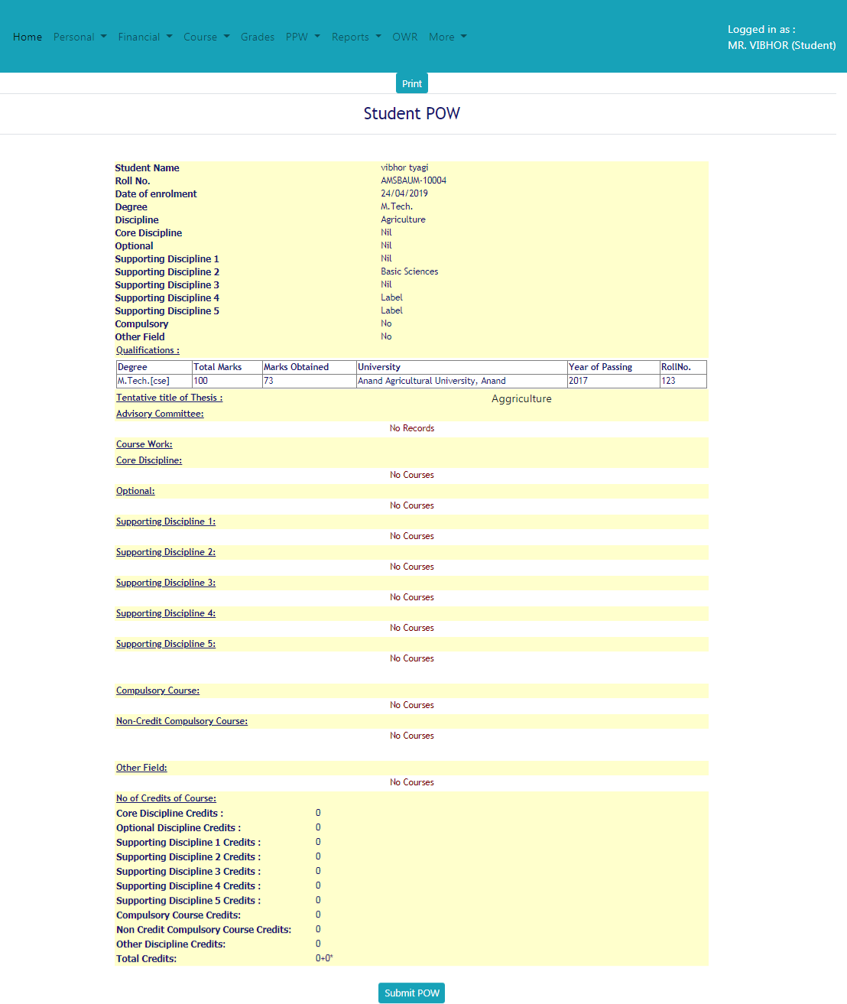

Fig. 4.7: Plan of Post Graduate Work (PPW)