AMS - UHS Bagalkot
https://amsuhs.icar.gov.in

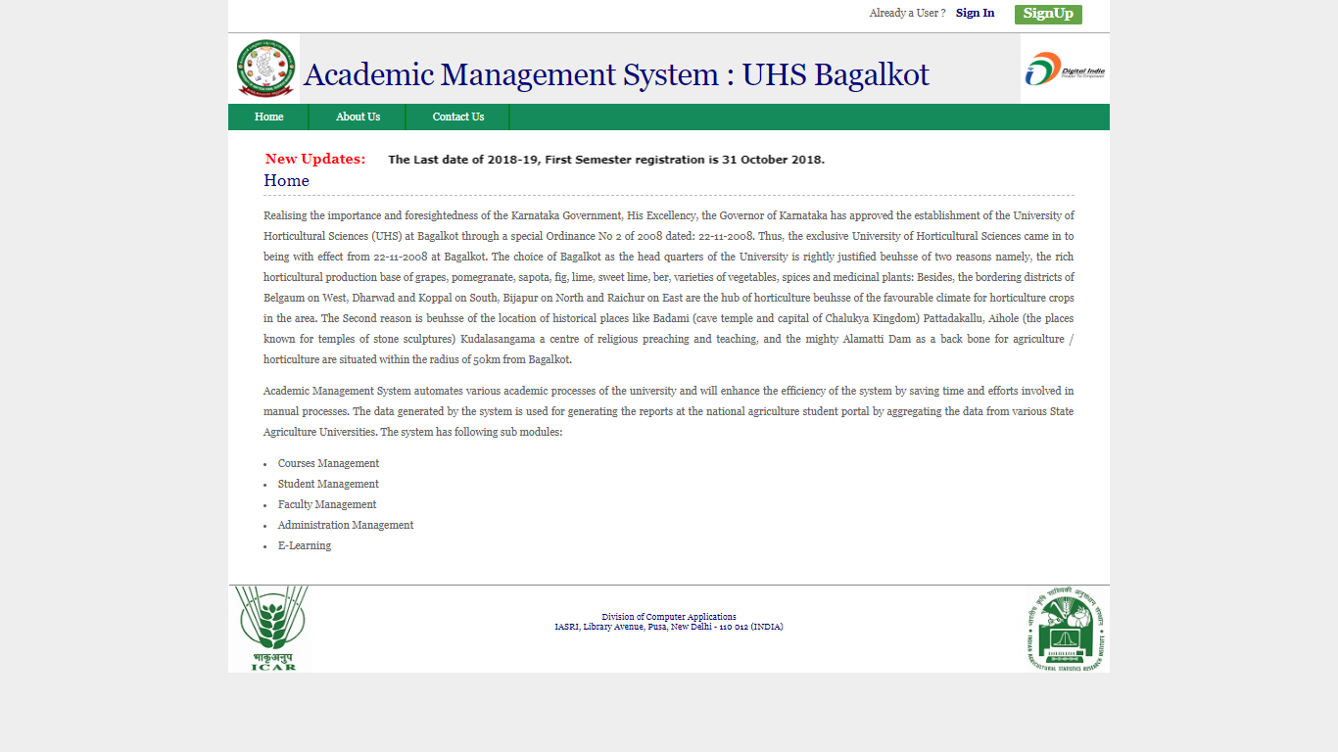

Academic Management System for UHS Bagalkot has been deployed during Oct 2017, and continues to be customized as per their needs. The AMS automates various academic processes of the university and enhances the efficiency of the overall system by saving time and efforts reducing manual processes.
The data collated by the system is used for generating the reports that are being used by the respective users of the system directly, viz. Students, Professors, Faculties, Controller of Examination, Head of Departments & Deans etc. The first batch of students admitted on to the AMS is the batch of 2017-18 of MSc(Horticulture) and PhD. Since then all the university students (both UG & PG) are admitted through the AMS only.
Regular SKYPE/LYNC meetings have been conducted with UHS Team from time to time to provide support and for gathering requirements for further customization.
The most recent development encompasses the following functionalities: -
- Additional Examiner for Qualifying Examination & Thesis submission
The feature empowers the Dean PGS to assign Additional & External Examiner for classified delegation of roles for activities like: -
  - Qualifying Examination, and
  - Thesis submission

- Online Fee-submission (using SBI ePay)
The feature to collect different categories and types of fees, by students, has been implemented and is being tested by the UHS and IASRI Team.
Listing of Students – Discipline-wise
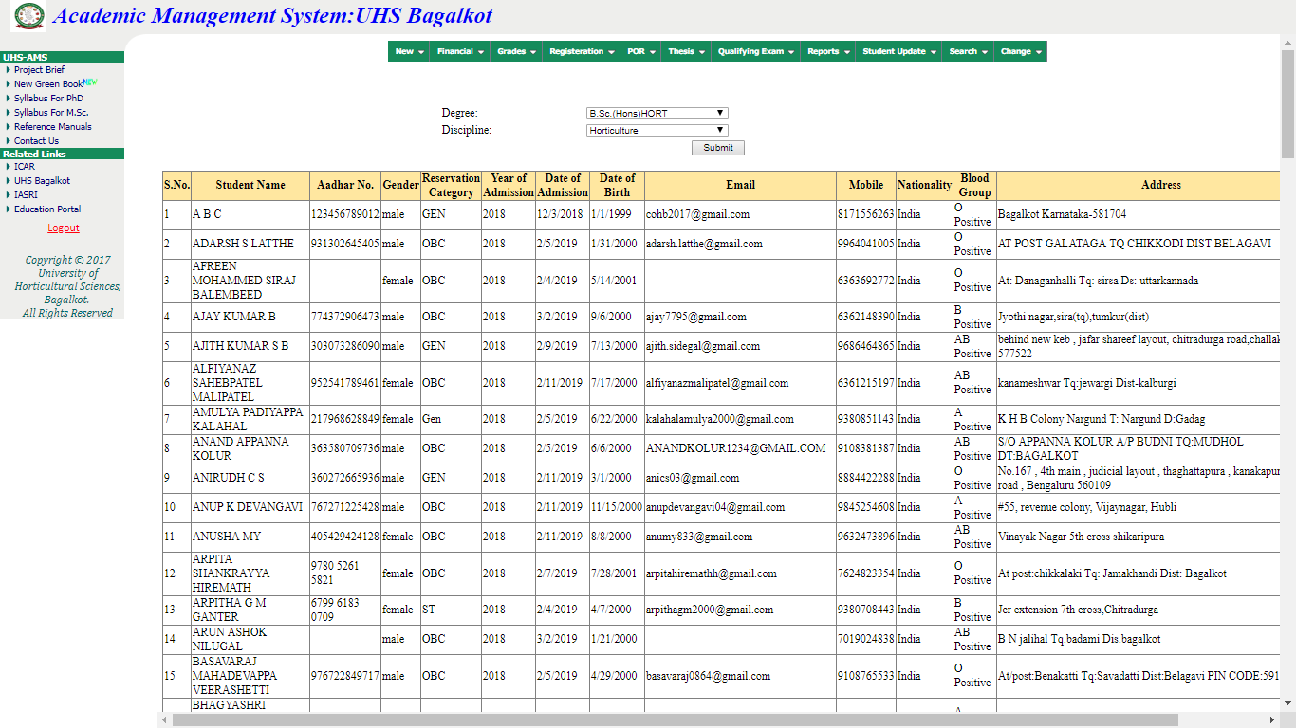

List of Students – Discipline-wise(Quota based)
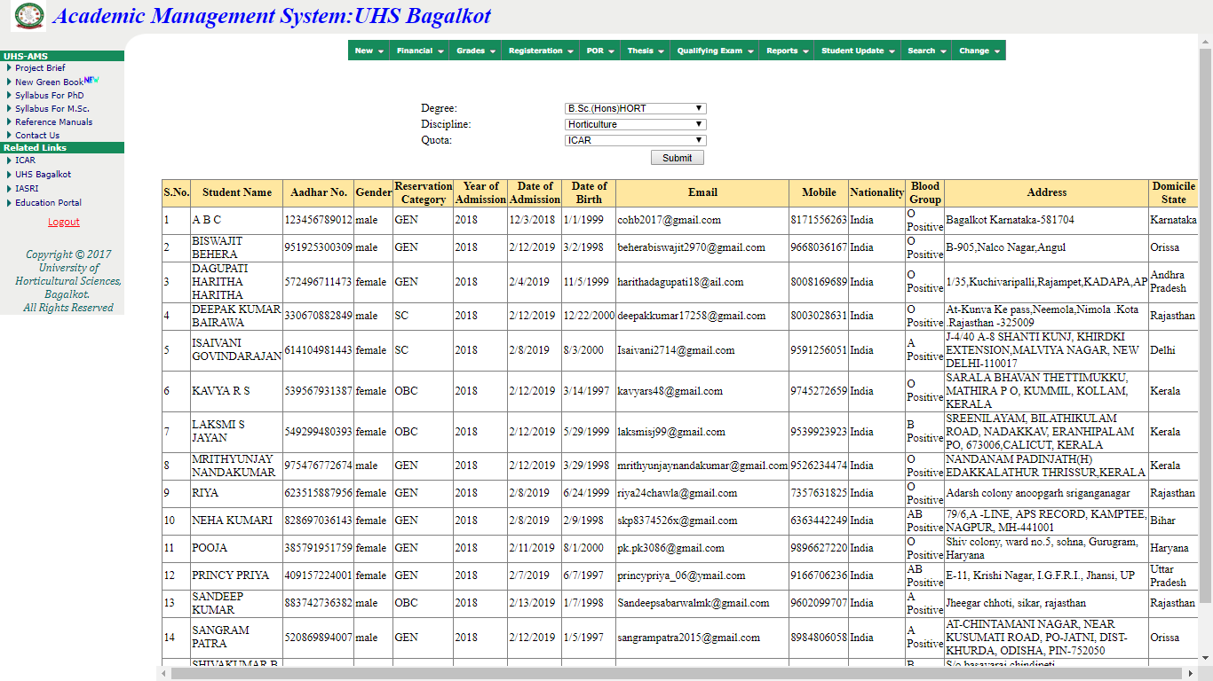

Online Fee Submission by Student using SBI ePay

Snapshot#1 – Select Fees (using Test Data)
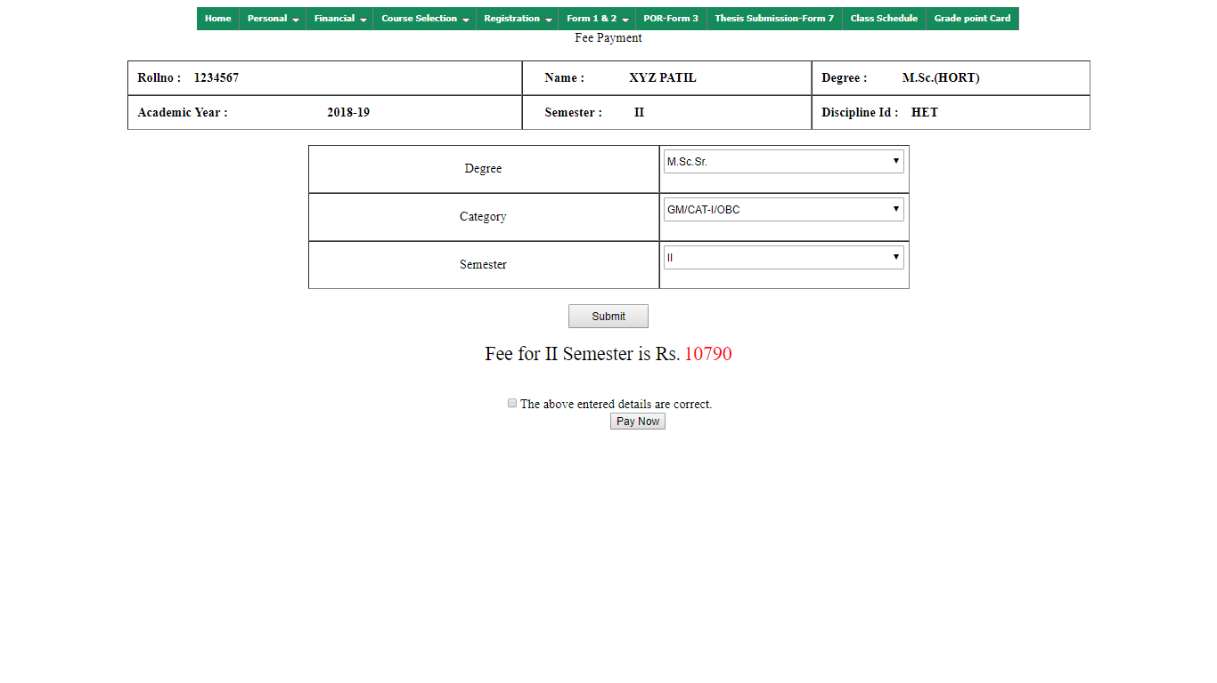
Snapshot#2 – Submit Fees (using Test Data)
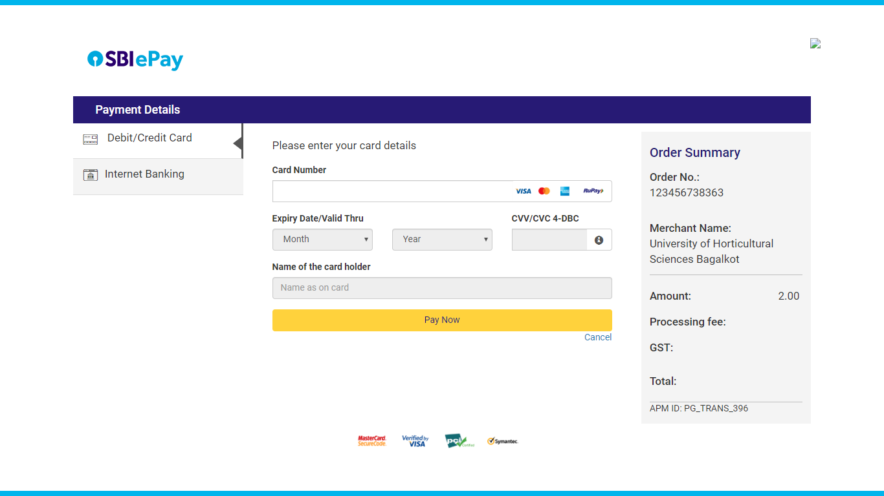

Qualifying Examination Marks Uploading Feature, for User Role: PG Coordinator
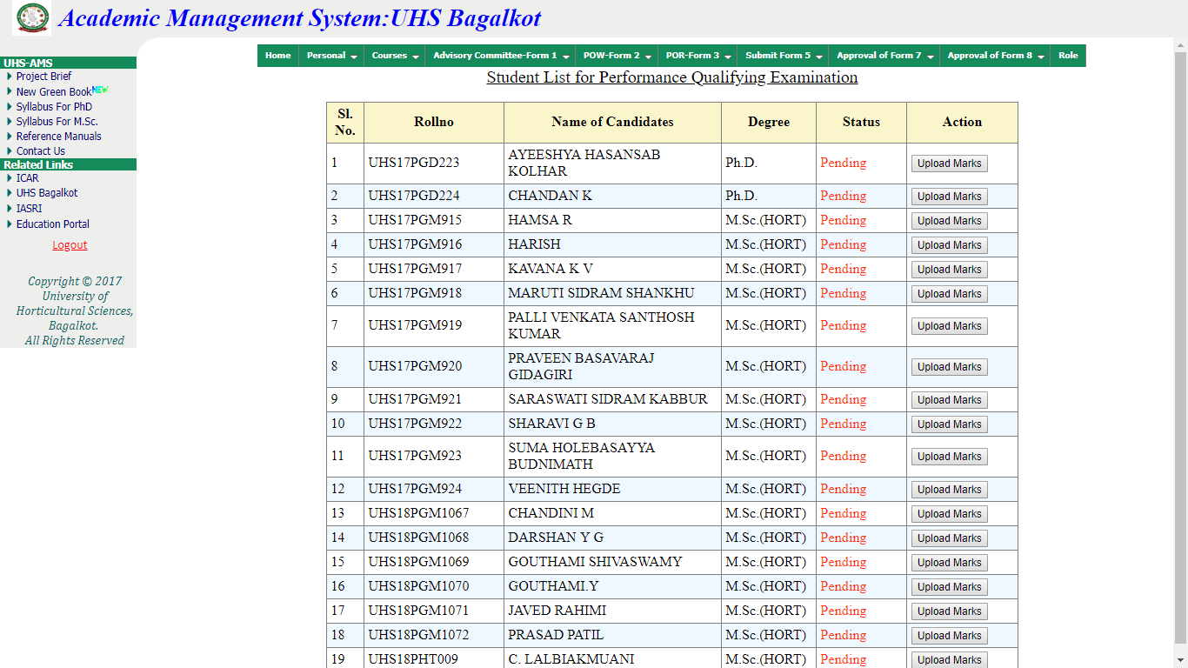

Course-wise Examination Marks Uploading Feature, User Role: CoE

